**Unit 0 Investigation 4**

Name: ____________________________

Period: _____

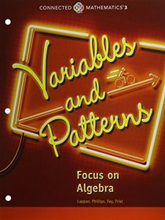

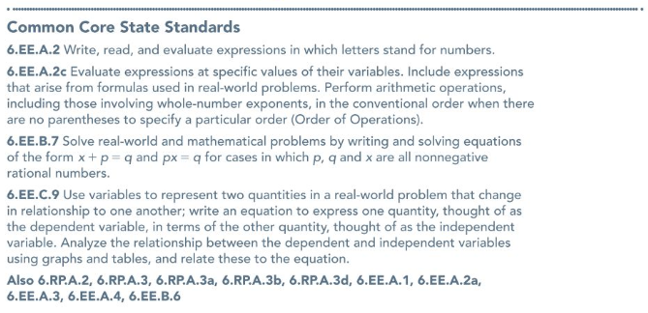

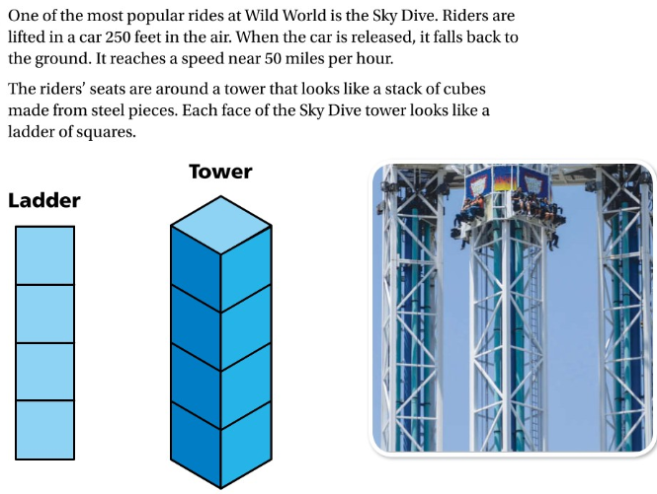**Investigation 4.1 Notes:**



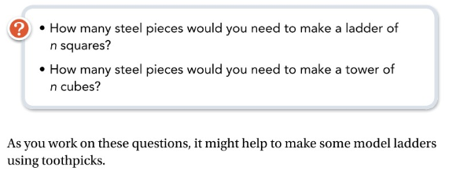

**Problem 4.1:**

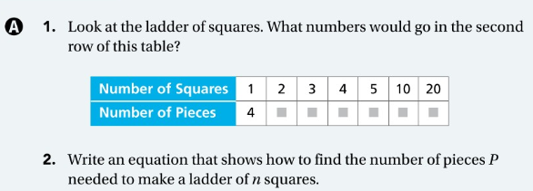

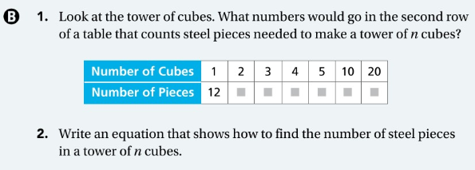

**Investigation 4.2 Notes:**

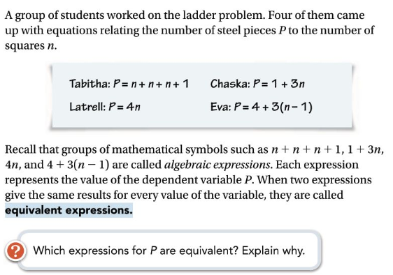

**Problem 4.2:**



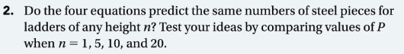





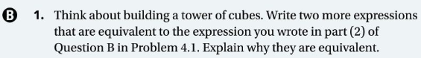



**Investigation 4.3 Notes:**

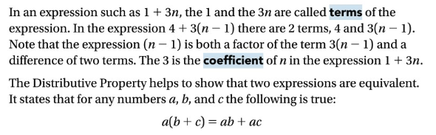

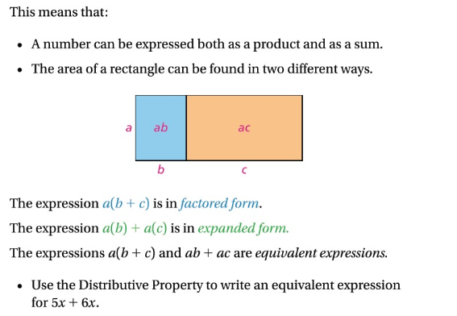



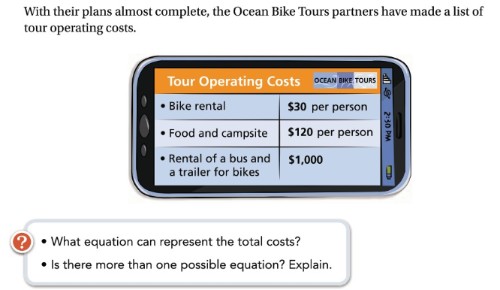

**Problem 4.3:**

